Error received while starting the redis server

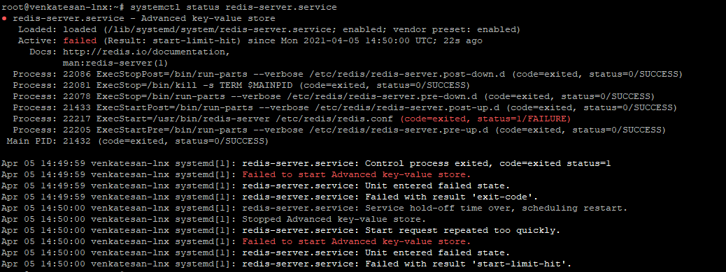

* Redis server was not started due to log file path was updated wrongly in redis config file **/etc/redis/redis.conf file**
* Corrected the Log file storage Path - **/var/log/redis/redis-server.log**
* One more error received **No such file or directory - pidfile /var/run/redis/redis-server.pid**
* Created the directory by below commands and changed the ownership

mkdir /var/run/redis

chown redis /var/run/redis

* Restarted the redis service by below commands

systemctl restart redis-server.service

* Trouble shooted commands, Config and Log file path

Journalctl –xe

systemctl status redis

systemctl daemon-reload

vi /etc/systemd/system/redis.service

tail -f redis-server.log

* Redis service has been started and below is the output

